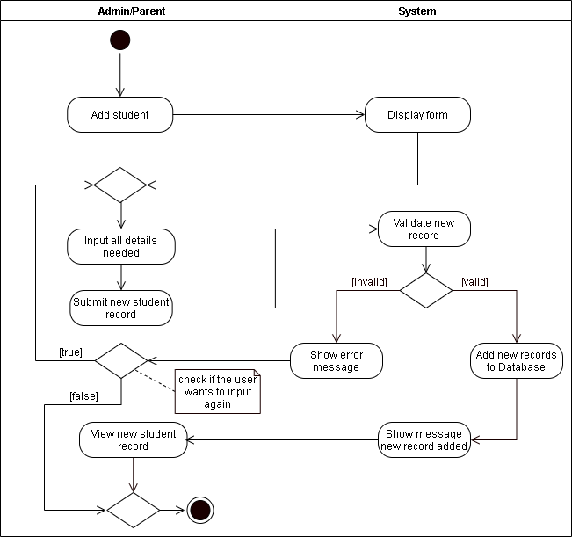

**Figure 1. Activity Diagram for Add Students**

Figure 1 shows the diagram for Add Students. The Admin will add new student in menu, the system will display the form. After completing the details, the system will validate if there is a new record. If the system accepts a unique record, it will now proceed on the adding of user records. Otherwise, the system will show an error message and will need to recreate the process of adding users.

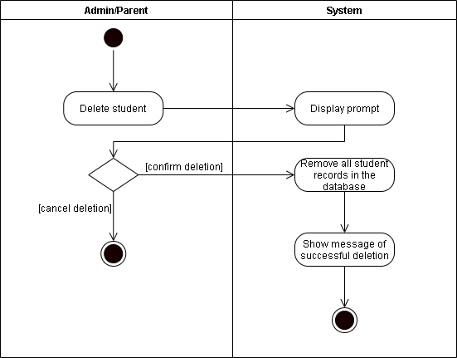

**Figure 2. Activity Diagram for Delete Students**

Figure 2 shows the diagram for Delete Students. The Admin will delete student in menu, the system will display the prompt. After displaying the details, the system will confirm deletion. If confirmed, the system will remove the student on the database record and will show a message of successful deletion.

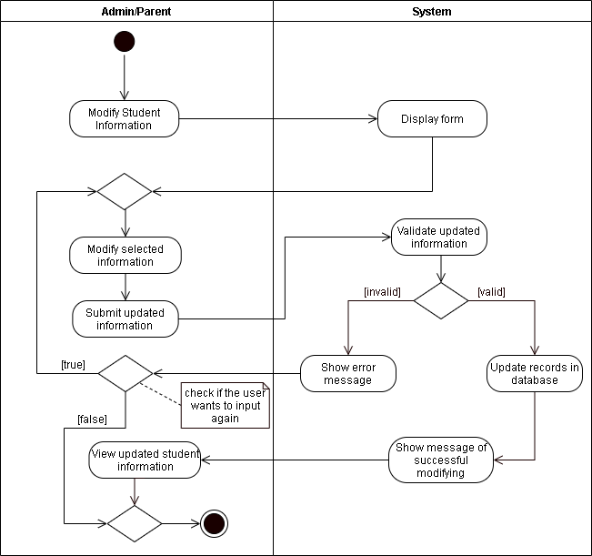

**Figure 3. Activity Diagram for Modify Students**

Figure 3 shows the diagram for Modify Students. The Admin will modify student in menu, the system will display form. After completing the details, the system will validate the updated information. If the system is valid, the system will update the student on the database record and will show a message of successful deletion. Otherwise, the system will show an error message will check if the user wants to input again.

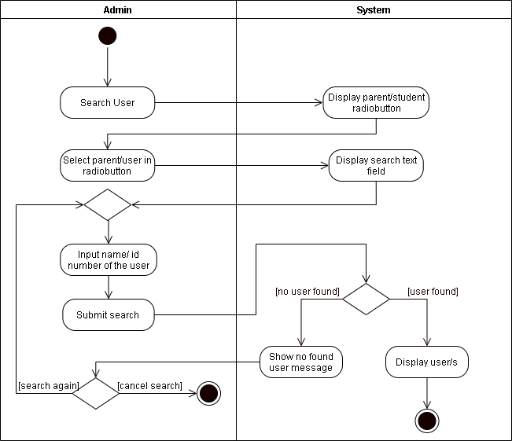

**Figure 4. Activity Diagram for Search User**

Figure 4 shows the diagram for Search User. The Admin will search user in menu, the system will display parent or student radio button. After completing the selection, the system will display the search text field. After completing the details, the system will now validate if the user is found on the database.

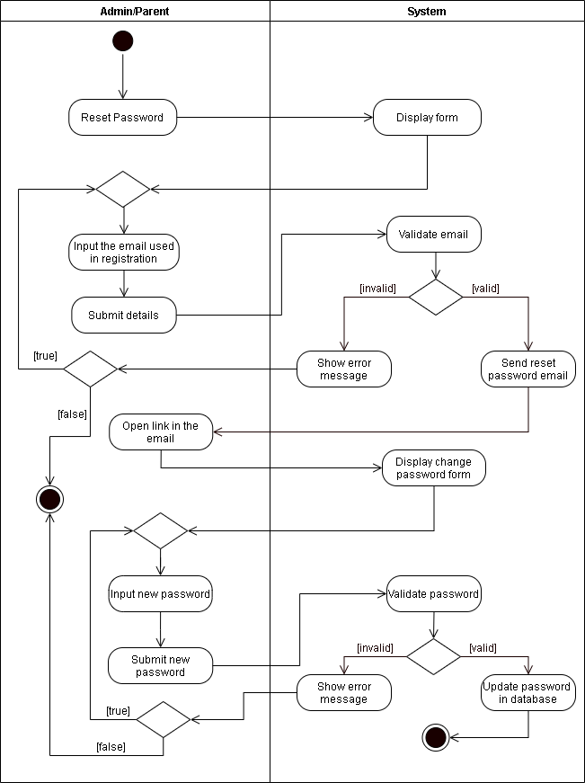

**Figure 5. Activity Diagram for Reset Password**

Figure 5 shows the diagram for Reset Password. The Admin/Parent can their reset password. The system will display a form for resetting the password. The user will input the email that is used in registration. Next, the system will now display a change password form. After completing the details of the new password, the system will validate the password. If the password and re-enter password are the same, the system will update the new database. Otherwise, the system will show an error message.

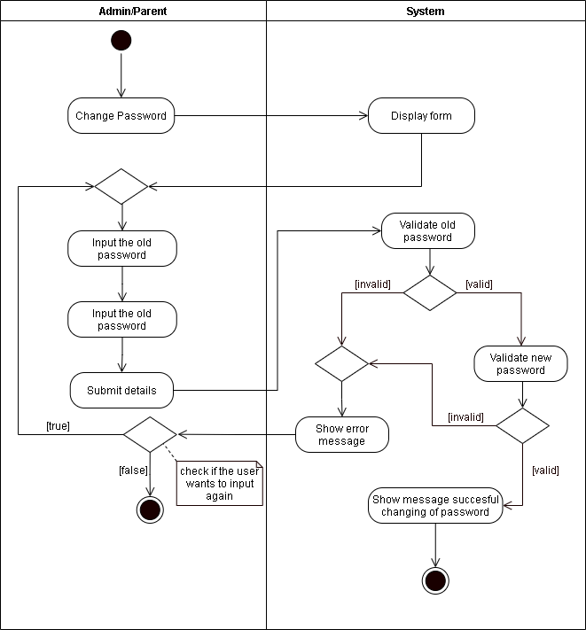

**Figure 6. Activity Diagram for Change Password**

Figure 6 shows the diagram for Change Password. The Admin/Parent will change password in menu, the system will display form for changing of password. After inputting the old password, the system will validate the old password. If the password and re-enter password are the same, the system will update the new database. Otherwise, the system will show an error message.

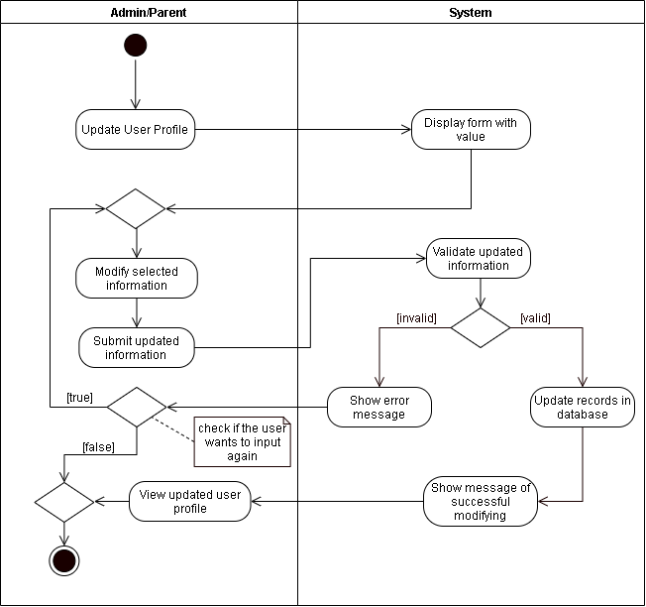

**Figure 6. Activity Diagram for Change Password**

Figure 6 shows the diagram for Change Password. The Admin/Parent will change password in menu, the system will display form for changing of password. After inputting the old password, the system will validate the old password. If the password and re-enter password are the same, the system will update the new database. Otherwise, the system will show an error message.



**Figure 7. Activity Diagram for Update User Profile**

Figure 7 shows the diagram for Update User Profile. The Admin/Parent will update profile in menu, the system will display form with value. After completing the form information, the system will validate the updated information. If the information is valid, the system will update the record in database. Otherwise, the system will show an error message.

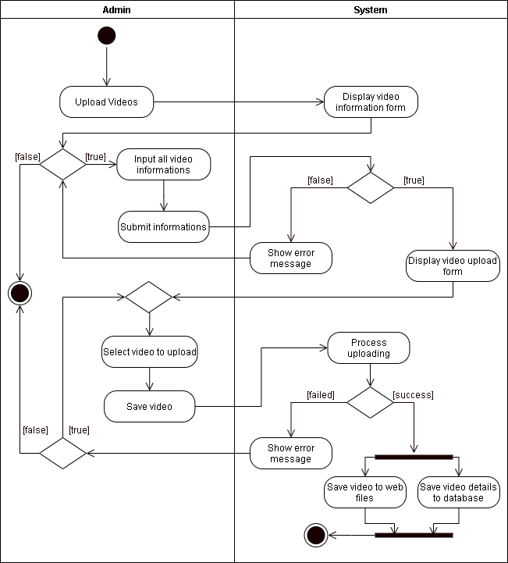

**Figure 8. Activity Diagram for Video Subsystem**

Figure 8 shows the diagram for Update User Profile. The Admin will upload video, the system will display the video information form. After completing the video information, the system will display video upload form. Next, after selecting the video to upload, the system will process loading. If the video is successfully uploaded, the system will proceed to save the video to web files and saved at the database. Otherwise, the system will show an error message.

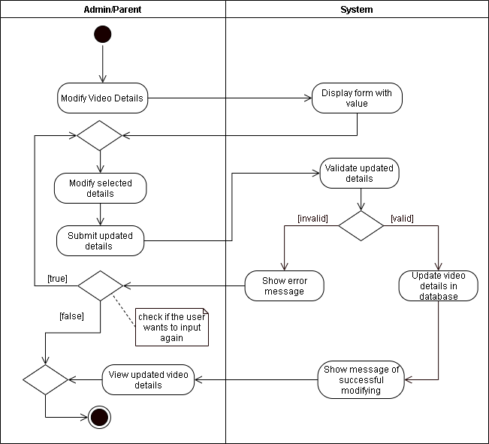

**Figure 9. Activity Diagram for Modify Video Detail**

Figure 9 shows the diagram for Modify Video Detail. The Admin will modify the video details, the system will display the video information form with value. After completing the form details, the system will validate the updated details of the video. If the video is valid, the video will be stored in the database otherwise, the system will show an error message.

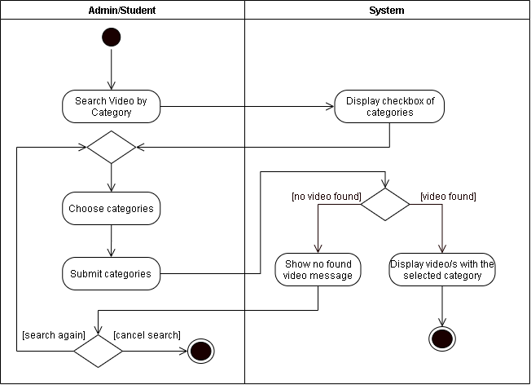

**Figure 10. Activity Diagram for Category Search**

Figure 10 shows the diagram for Category Search. The Admin/Student will search video by category, the system will display checkbox of categories. After choosing specific category, it will now proceed to the system and check if the video is found or not. If the video is found, the system will display the video that match within the selected category, else the system will show video not founded.

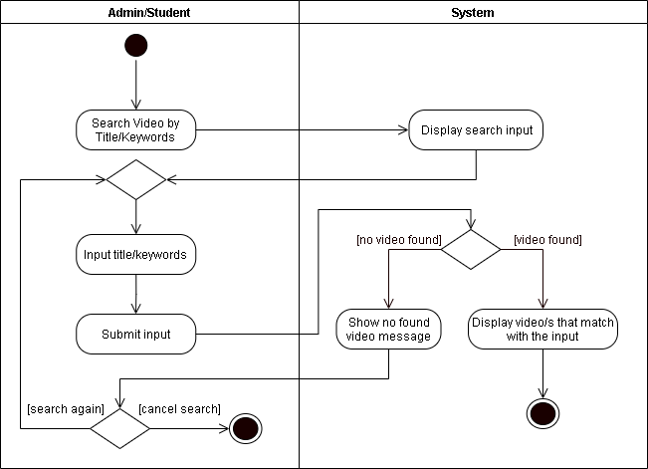

**Figure 11. Activity Diagram for Title Search**

Figure 11 shows the diagram for Title Search. The Admin/Student will search video by title, the system will display search input. After searching specific title/keywords, it will now proceed to the system and will check if the video is found or not. If the video is found, the system will display the video that match within the input, else the system will show video not founded

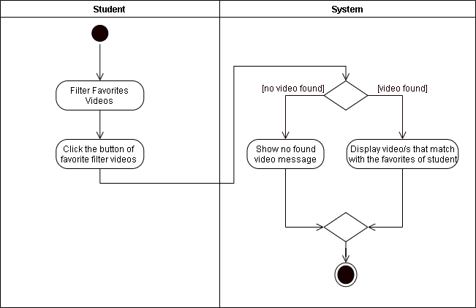

**Figure 12. Activity Diagram for Favorite Filter**

Figure 12 shows the diagram for Favorite Filter. The Student will filter favorite videos. After clicking the button for filter videos, the system will check if the video is found or not. If the video is found, the system will display video that match the favorites of student, else the system will show video not founded.